Revision History

|  |  |  |
| --- | --- | --- |
| **Revision** | **Description of Change** | **Revision date** |
| 1.0 | Test report phase 1 | 2019-11-13 |
|  |  |  |
|  |  |  |
|  |  |  |
|  |  |  |
|  |  |  |
|  |  |  |
|  |  |  |
|  |  |  |
|  |  |  |
|  |  |  |

**TABLE OF CONTENTS**

[Introduction 3](#_Toc24553696)

[1 Test Object 3](#_Toc24553697)

[2 Testing work （Phase 1） 5](#_Toc24553698)

[2.1 Test Environment 5](#_Toc24553699)

[2.2 Test scenario and strategy 6](#_Toc24553700)

[2.3 Test Tool 6](#_Toc24553701)

[2.4 Database setting 7](#_Toc24553702)

[2.5 IIS setting 7](#_Toc24553703)

[2.6 Test Object version 7](#_Toc24553704)

[2.7 Background data 7](#_Toc24553705)

[2.8 Test Error 7](#_Toc24553706)

[2.9 Test result of PS server 7](#_Toc24553707)

[Test result of PS transactions 7](#_Toc24553708)

[Transaction summary result of PS 9](#_Toc24553709)

[Transaction response time result of PS 10](#_Toc24553710)

[2.10 Test result of Web service 10](#_Toc24553711)

[Test Statistic Report of Web 10](#_Toc24553712)

[Transaction summary result of Web 12](#_Toc24553713)

[Transaction response time result of Web 13](#_Toc24553714)

[2.11 Error Analyze: 14](#_Toc24553715)

[2.12 Test Conclusion 16](#_Toc24553716)

# Introduction

The PUMA MR3 performance testing works will focus on main work flow of the Print Server of Kiosk (PS). Develop team had do some enhance operations for system. We will verify these change should works and do not affect the main work flow.

The PUMA PS system will integrated with other 3rd systems like HIS, RIS, LIS etc. System will synchronize 3rd party data and provide the film include gray and color type and report printing services. The PUMA system will integrate with PS and get the patient information and images data from PS system.

We should confirm the performance of PS system will meet the requirements on real work environments. Ensure the new added features will not affect main workflow of PS system.

# Test Object

The PUMA system will support film and report printing and notice push service for different departments of entire hospital.

We will integrate the 3rd party system and patients can print their films and reports in ONE terminal. The patient can print their color films to paper or films. Patients can query different information, and get report status notice service from the product.

PUMA MR1 system will provide the patient images data upload service for Cloud Film system. System will provide the patient can print their color films to film or paper media. The patient can view the image files including picture and DICOM type from WeChat platform or by scanning from 2D image code.

Notice: We will not test the images upload feature in performance testing.

The architecture as follow:

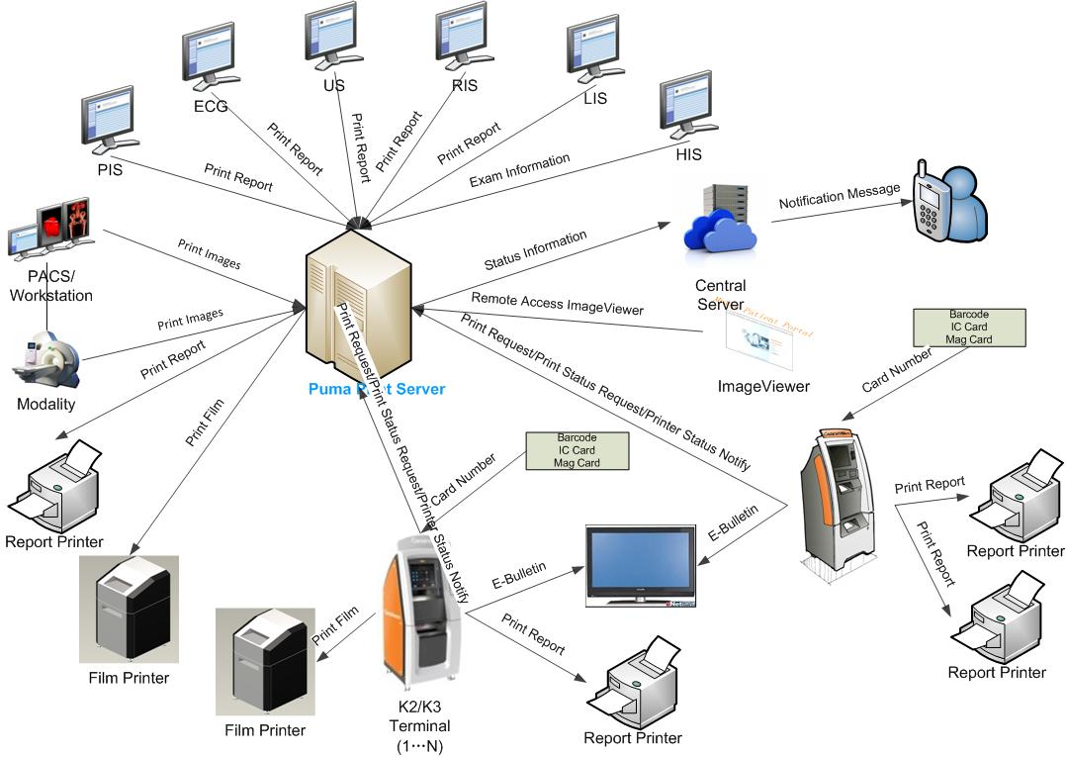Figure 3.1.2

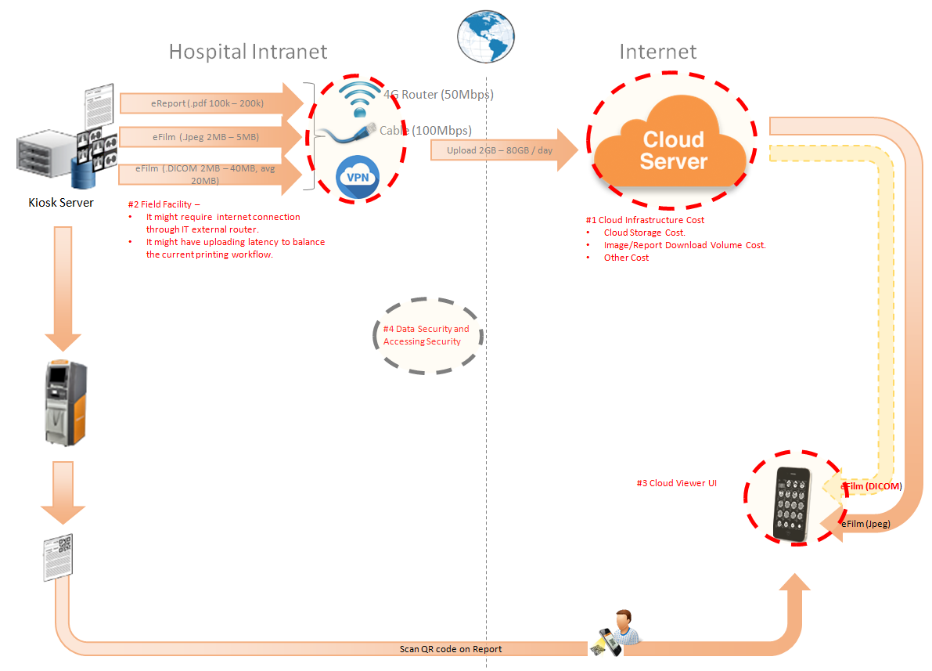Figure 3.1.2

The performance testing work will focus on the PS system. We will simulate the web service call and send them to PS server, and monitor the transactions response time, service performance and hardware resource usage. This scenario will include the 3rd request, report archived, gray and color film and report print, web query and update status operations etc.

# Testing work （Phase 1）

This phase is test the performance of single server with windows 2016 on B3400 version. Ensure the PS system can works well on the new design.

## Test Environment

The detailed hardware configurations of all servers are described as follow:

|  |  |  |  |  |  |  |
| --- | --- | --- | --- | --- | --- | --- |
| **Computer name** | **CPU** | **Memory** | **HD** | **OS** | **Other** | **Comments** |
| PUMA Server | Intel(R) Xeon® Bronze CPU 3140 @ 1.70 \* 6 | 16GB | 300GB+ 8T GB | Windows 2012 Standard 64bit |  |  |
| PUMA virtual server | Intel(R) Xeon® Bronze CPU 3140 @ 1.70 \* 6 | 12GB | 7T | Windows 2008 Standard 64bit | SQL Server 2008 Sp3 | PS 3.0.5.0.3600 |

Table 1 Hardware Configuration

## Test scenario and strategy

Virtual User: 59 Users

Duration: 8 hour

Description: Use the test tool simulates the patient operations. Monitor the server software and hardware resource usage. The detail information as follow:

1. Use automation tool simulate the doctor print film work. Simulate 10 workstations print films to PS server every 90 seconds
2. Use LR tool simulate 8 K2/K3 terminals to print gray films. Each client prints one film which size is 10MB random 60 to 120 seconds.
3. Use LR tool simulate 21 users to do paper report archive and print operations. Each client archive report in random 60 to 120 seconds and size is random with 100kb or 4Mb.
4. The OCR setting will has rule configuration from test tool in step1 and thread setting is set as 5. The OCR rule will has ROI setting of patient id and accession number in OCR.
5. Simulate 10 users to do the query information, view monitor page, query reconciliation films and report, expand the record, change the status, set holding time and other operations in work list. The users will execute the operations random 60 to 120 seconds.
6. Monitor the transaction response time.
7. Monitor the hardware resource usage on PS.
8. Monitor the resource usage for database on PS.
9. Start/Stop 2 virtual users every 10 seconds and run the scenario for 7\*24 hours.

Note:

We will do the performance testing work under stress for system. If system can work well under current stress and the transaction process ability meets the requirement, we will give the conclusion the system performance is pass.

## Test Tool

Load Runner 12.

## Database setting

Memory: Set the min and max memory size to 6GB.

Index fill factor: 80.

Settings: Cost threshold for parallelism to 60.

## IIS setting

Connection: Set the max connection value to 4000 and keep other setting as default.

## Test Object version

PUMA 3.0.5.0 B36 + patch1.

## Background data

We will simulate 1,000,000 records in the PS as background data. The data size is calculated by typical site. We will stop the SMS and LRU services of PS in order to keep the history data. These data will be added by automation scripts, test tool or SQL script. The detail data information as follow:

|  |  |  |
| --- | --- | --- |
| No. | Items | Amount |
| 1 | Patients | >=1,000,000 |
| 2 | Films | >=1,000,000 |
| 3 | Reports | >=1,000,000 |
| 4 | Exams | >=1,000,000 |
| 5 | Unprinted Films | >=700,000 |
| 6 | Unprinted Reports | >=300,000 |

## Test Error

There are some transactions and test error during the testing work. We will analyze later.

## Test result of PS server

### Test result of PS transactions

After the performance testing works, the transactions result of PS print module as follow:

|  |  |
| --- | --- |
| Analysis Summary | Period: 2019/11/5 16:36 - 2019/11/12 16:46 |

|  |  |
| --- | --- |
| **Scenario Name:** | E:\ECS\Performance\Script\208\ScenarioPUMA\_MR2\_Reliability\_161.lrs |
| **Results in Session:** | c:\Users\Administrator\AppData\Local\Temp\res1175\res1175.lrr |
| **Duration:** | 7 days, 10 minutes and 18 seconds. |

|  |
| --- |
| Statistics Summary |

|  |  |  |
| --- | --- | --- |
| [**Maximum Running Vusers:**](file:///E:\B36%20reliability\B36_PS_reliability_report\PS%20_report\VuserStateGraph) |  | 29 |
| [**Total Throughput (bytes):**](file:///E:\B36%20reliability\B36_PS_reliability_report\PS%20_report\Throughput) | [Show SLA Results](slarules:total_throughput) | 269,222,851 |
| [**Average Throughput (bytes/second):**](file:///E:\B36%20reliability\B36_PS_reliability_report\PS%20_report\Throughput) | [Show SLA Results](slarules:average_throughput) | 445 |
| [**Total Hits:**](file:///E:\B36%20reliability\B36_PS_reliability_report\PS%20_report\HitsperSecond) | [Show SLA Results](slarules:total_hits) | 256,917 |
| [**Average Hits per Second:**](file:///E:\B36%20reliability\B36_PS_reliability_report\PS%20_report\HitsperSecond) | [Show SLA Results](slarules:average_hits) | 0.424 | [**View HTTP Responses Summary**](file:///E:\B36%20reliability\B36_PS_reliability_report\PS%20_report\PS%20_report.html#1) |
| [**Total Errors:**](file:///E:\B36%20reliability\B36_PS_reliability_report\PS%20_report\TotalErrorsPerSecond) | [Show SLA Results](slarules:errors_per_second) | 16,401 |  |

|  |  |  |
| --- | --- | --- |
| |  | | --- | | You can define SLA data using the [SLA configuration wizard](slaconfig:) | | You can analyze transaction behavior using the [Analyze Transaction mechanism](analyze:) | |

|  |
| --- |
| Transaction Summary |

|  |  |  |  |  |
| --- | --- | --- | --- | --- |
| [**Transactions:**](file:///E:\B36%20reliability\B36_PS_reliability_report\PS%20_report\Report\Report3.html) | Total Passed: 1,224,755 | Total Failed: 12,707 | Total Stopped: 2 | [**Average Response Time**](file:///E:\B36%20reliability\B36_PS_reliability_report\PS%20_report\Report\Report4.html) |

|  |  |  |  |  |  |  |
| --- | --- | --- | --- | --- | --- | --- |
| **Transaction Name** | **Minimum** | **Average** | **Maximum** | **Pass** | **Fail** | **Stop** |
| Create New Patient | 0.187 | 0.283 | 6.033 | 61,896 | 5 | 0 |
| Create Report PrintTask Fail | 0 | 0 | 0 | 0 | 26 | 0 |
| Film Create\_PrintTask | 0.32 | 1.391 | 15.959 | 25,085 | 5 | 0 |
| Film GetTaskID\_Fail | 0 | 0 | 0 | 0 | 15 | 0 |
| Film PrintTask | 0.11 | 0.316 | 24.024 | 25,075 | 0 | 0 |
| Film PrintTask\_Result\_Correct | 0 | 0 | 0.003 | 21,548 | 0 | 0 |
| Film PrintTask\_Result\_Fail | 0 | 0.001 | 0.016 | 3,526 | 0 | 0 |
| Film TerminalStatus | 0 | 0.055 | 4.298 | 25,072 | 3 | 0 |
| Film\_PrintStatus\_CheckService | 0.014 | 0.104 | 2.306 | 181,672 | 15 | 0 |
| Notify File 100k | 0.556 | 2.183 | 11.076 | 60,653 | 12 | 0 |
| Notify File 4M | 0.448 | 2.334 | 17.675 | 1,221 | 0 | 1 |
| Report Print Task Correct | 0 | 0 | 0.002 | 49,364 | 0 | 0 |
| Report Print Task fail | 0 | 0 | 0 | 0 | 12,495 | 0 |
| Report Create\_PrintTask | 0.339 | 1.414 | 7.511 | 61,855 | 26 | 0 |
| Report GetReportID\_fail | 0 | 0 | 0 | 0 | 13 | 0 |
| Report GetReportPath\_fail | 0 | 0 | 0 | 0 | 16 | 0 |
| Report PrintTask | 0.196 | 0.478 | 10.736 | 61,847 | 7 | 0 |
| Report PrintTask Status Check | 0.014 | 0.123 | 1.858 | 212,798 | 27 | 0 |
| Report QueryFilmReportInfo | 0.363 | 1.453 | 8.285 | 123,773 | 21 | 1 |
| Report TerminalStatus | 0.014 | 0.061 | 3.033 | 123,762 | 6 | 0 |
| Report Update PrintTask | 0.016 | 0.118 | 9.537 | 61,850 | 4 | 0 |
| Report Update report printer info | 0.008 | 0.044 | 1.135 | 123,758 | 11 | 0 |

|  |  |  |  |  |  |  |
| --- | --- | --- | --- | --- | --- | --- |
| **Service Level Agreement Legend:** | E:\B36 reliability\B36_PS_reliability_report\PS _report\Report\led_ok.gif | Pass | E:\B36 reliability\B36_PS_reliability_report\PS _report\Report\led_error.gif | Fail | E:\B36 reliability\B36_PS_reliability_report\PS _report\Report\led_no_data.gif | No Data |

|  |
| --- |
| HTTP Responses Summary |

|  |  |  |
| --- | --- | --- |
| **HTTP Responses** | **Total** | **Per second** |
| HTTP\_200 | 256,906 | 0.424 |
| HTTP\_503 | 11 | 0 |

|  |
| --- |
|  |
| |  | | --- | | **Filters:**(do not Include Think Time) | |  | |

Follow the summary report: we can see there are many transactions failed during the testing. The root cause will analyze in other chapter.

### Transaction summary result of PS

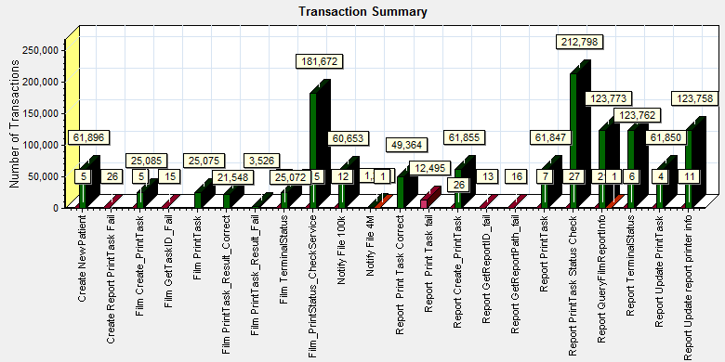

|  |  |  |
| --- | --- | --- |
| Color | Scale | Measurement |
|  | 1 | Fail |
|  | 1 | Pass |
|  | 1 | Stop |

Follow the figure; we can see there are some transactions failed during the testing work.

### Transaction response time result of PS

We can get the transaction response time information from the figure as follow:



|  |  |  |  |  |  |  |  |  |  |  |  |  |
| --- | --- | --- | --- | --- | --- | --- | --- | --- | --- | --- | --- | --- |
| |  |  |  | | --- | --- | --- | | Color | Scale | Measurement | |  | 1 | Fail | |  | 1 | Pass | |  | 1 | Stop | |
|  |
|  |
| E:\B36 reliability\B36_PS_reliability_report\PS _report\Report\dot_trans.gif |
|  |
| |  | | --- | | **Description:** Displays the number of transactions that passed, failed, stopped, or ended with errors. | |

Transaction response time

This figure information shows all transaction response time. We can analysis that there are no transaction response time more than 3 seconds. It`s good performance for our system.

## Test result of Web service

### Test Statistic Report of Web

After the performance testing works, the transactions result of we module as follow:

|  |  |  |  |  |  |  |  |  |  |  |  |  |  |  |  |  |  |  |  |  |  |  |  |  |  |  |  |  |  |  |  |  |  |  |  |  |  |  |  |  |  |  |  |  |  |  |  |  |  |  |  |  |  |  |  |  |  |  |
| --- | --- | --- | --- | --- | --- | --- | --- | --- | --- | --- | --- | --- | --- | --- | --- | --- | --- | --- | --- | --- | --- | --- | --- | --- | --- | --- | --- | --- | --- | --- | --- | --- | --- | --- | --- | --- | --- | --- | --- | --- | --- | --- | --- | --- | --- | --- | --- | --- | --- | --- | --- | --- | --- | --- | --- | --- | --- | --- |
| |  |  |  |  |  |  |  |  |  |  |  |  |  |  |  |  |  |  |  |  |  |  |  |  |  |  |  |  |  |  |  |  |  |  |  |  |  |  |  |  |  |  |  |  |  |  |  |  |  |  |  |  |  |  |  |  | | --- | --- | --- | --- | --- | --- | --- | --- | --- | --- | --- | --- | --- | --- | --- | --- | --- | --- | --- | --- | --- | --- | --- | --- | --- | --- | --- | --- | --- | --- | --- | --- | --- | --- | --- | --- | --- | --- | --- | --- | --- | --- | --- | --- | --- | --- | --- | --- | --- | --- | --- | --- | --- | --- | --- | --- | | |  | | --- | | Statistics Summary |      |  |  |  | | --- | --- | --- | | [**Maximum Running Vusers:**](file:///E:\B36%20reliability\Web_result\Report\Report0.html) |  | 10 | | [**Total Throughput (bytes):**](file:///E:\B36%20reliability\Web_result\Report\Report2.html) |  | 1.0453023866E11 | |  |  |  | |  |  |  | | [**Average Throughput (bytes/second):**](file:///E:\B36%20reliability\Web_result\Report\Report2.html) |  | 172,707 | |  |  |  | |  |  |  | | [**Total Hits:**](file:///E:\B36%20reliability\Web_result\Report\Report1.html) |  | 2,675,655 | |  |  |  | |  |  |  | | [**Average Hits per Second:**](file:///E:\B36%20reliability\Web_result\Report\Report1.html) |  | 4.421 | [**View HTTP Responses Summary**](file:///E:\B36%20reliability\Web_result\Report\summary.html#1) | |  |  |  |  | |  |  |  |  | | **Total Errors:** |  | 105 |  | |  |  |  |  | |  |  |  |  | | |  | | |
| Transaction Summary |

|  |  |  |  |  |
| --- | --- | --- | --- | --- |
| [**Transactions:**](file:///E:\B36%20reliability\Web_result\Report\Report3.html) | Total Passed: 265,244 | Total Failed: 16 | Total Stopped: 0 | [**Average Response Time**](file:///E:\B36%20reliability\Web_result\Report\Report4.html) |

|  |  |  |  |
| --- | --- | --- | --- |
|  | **Pass** | **Fail** | **Stop** |
| Total | 265,244 | 16 | 0 |

|  |  |  |  |  |  |  |
| --- | --- | --- | --- | --- | --- | --- |
| **Transaction Name** | **Minimum** | **Average** | **Maximum** | **Pass** | **Fail** | **Stop** |
| ExpandFilmRecord | 0 | 0.027 | 1.86 | 8,577 | 1 | 0 |
| ExpandReportRecord | 0 | 0.02 | 1.172 | 8,577 | 1 | 0 |
| GetDepartmentInfo | 0 | 0.027 | 2.453 | 11,466 | 0 | 0 |
| Reconlication\_Film\_all | 5.044 | 5.605 | 33.113 | 9,865 | 5 | 0 |
| Reconlication\_Report\_All | 0.015 | 0.125 | 10.423 | 9,867 | 3 | 0 |
| SetPrintMode | 0.015 | 0.128 | 10.315 | 8,578 | 0 | 0 |
| SetStatusOfFilmWithExpand\_NOTprinted | 0.031 | 0.158 | 4.563 | 1,648 | 0 | 0 |
| SetStatusOfFilmWithExpand\_Printed | 0.031 | 0.167 | 3.672 | 1,600 | 0 | 0 |
| SetStatusOfFilmWithExpand\_Unprinted | 0.031 | 0.167 | 10.955 | 1,559 | 0 | 0 |
| SetStatusOfFilmWithoutExpand\_NOTprinted | 0.016 | 0.13 | 2.626 | 1,594 | 0 | 0 |
| SetStatusOfFilmWithoutExpand\_printed | 0.016 | 0.137 | 3.391 | 1,613 | 0 | 0 |
| SetStatusOfFilmWithoutExpand\_unprinted | 0.016 | 0.131 | 16.221 | 1,611 | 0 | 0 |
| SetStatusOfReportWithExpand\_NOTprinted | 0.031 | 0.151 | 4.017 | 1,607 | 0 | 0 |
| SetStatusOfReportWithExpand\_printed | 0.031 | 0.151 | 3.126 | 1,590 | 0 | 0 |
| SetStatusOfReportWithExpand\_unprinted | 0.031 | 0.14 | 3.86 | 1,622 | 0 | 0 |
| SetStatusOfReportWithoutExpand\_NOTprinted | 0.028 | 0.12 | 5.751 | 1,637 | 0 | 0 |
| SetStatusOfReportWithoutExpand\_printed | 0.029 | 0.125 | 8.971 | 1,558 | 0 | 0 |
| SetStatusOfReportWithoutExpand\_unprinted | 0.03 | 0.114 | 3.282 | 1,611 | 0 | 0 |
| SetTheHoldingTime | 0.015 | 0.092 | 7.095 | 8,578 | 0 | 0 |
| Terminal\_monitor | 0.156 | 0.377 | 23.769 | 11,466 | 0 | 0 |
| User\_login | 0.031 | 0.514 | 27.378 | 49,727 | 4 | 0 |
| worklist\_query\_ACC | 0 | 0.047 | 2.219 | 1,237 | 0 | 0 |
| worklist\_query\_LastMonth | 0.022 | 0.096 | 2.031 | 1,310 | 0 | 0 |
| worklist\_query\_LastTwoToday | 0.015 | 0.072 | 3.5 | 1,271 | 1 | 0 |
| worklist\_query\_Lastweek | 0.022 | 0.081 | 4.407 | 1,335 | 0 | 0 |
| worklist\_query\_Patient\_PatientName | 0 | 0.049 | 1.735 | 1,271 | 1 | 0 |
| worklist\_query\_Patient\_PID | 0 | 0.058 | 1.891 | 1,337 | 0 | 0 |
| Worklist\_Query\_Today | 0.015 | 0.084 | 8.454 | 1,158 | 0 | 0 |
| WorlkList\_Query\_randomTime | 0.023 | 0.293 | 6.797 | 1,267 | 0 | 0 |

|  |  |  |  |  |  |  |
| --- | --- | --- | --- | --- | --- | --- |
| **Service Level Agreement Legend:** | E:\B36 reliability\Web_result\Report\led_ok.gif | Pass | E:\B36 reliability\Web_result\Report\led_error.gif | Fail | E:\B36 reliability\Web_result\Report\led_no_data.gif | No Data |

|  |
| --- |
| HTTP Responses Summary |

|  |  |  |
| --- | --- | --- |
| **HTTP Responses** | **Total** | **Per second** |
| HTTP\_200 | 2,576,426 | 4.257 |
| HTTP\_302 | 49,727 | 0.082 |
| HTTP\_401 | 49,350 | 0.082 |
| HTTP\_500 | 3 | 0 |
| HTTP\_503 | 149 | 0 |

Follow the summary report; we can see all the transactions have passed. Most transaction response time is under the 3 seconds. But the transaction Reconlication\_Film\_all average time is 5 seconds, we need to enhance the design for this transaction.

### Transaction summary result of Web

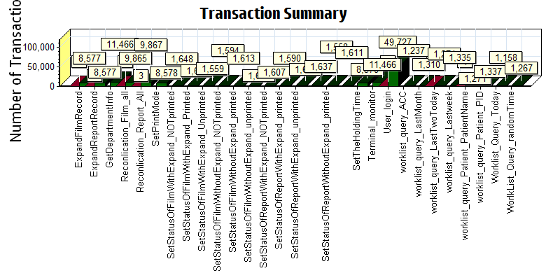

|  |
| --- |
|  |
| |  |  |  | | --- | --- | --- | | Color | Scale | Measurement | |  | 1 | Fail | |  | 1 | Pass | |

We can see that there are some transactions failed during the testing works.

### Transaction response time result of Web

We can get the transaction response time information from the figure as follow:

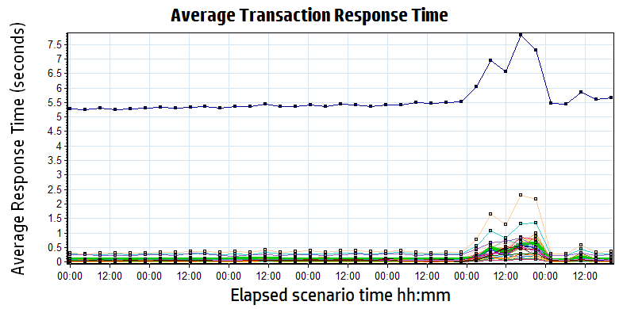

|  |  |  |  |  |  |  |  |  |  |  |  |  |  |  |  |  |  |  |  |  |  |  |  |  |  |  |  |  |  |  |  |  |  |  |  |  |  |  |  |  |  |  |  |  |  |  |  |  |  |  |  |  |  |  |  |  |  |  |  |  |  |  |  |  |  |  |  |  |  |  |  |  |  |  |  |  |  |  |  |  |  |  |  |  |  |  |  |  |  |  |  |  |  |  |  |  |  |  |  |  |  |  |  |  |  |  |  |  |  |  |  |  |  |  |  |  |  |  |  |  |  |  |  |  |  |  |  |  |  |  |  |  |  |  |  |  |  |  |  |  |  |  |  |  |  |  |  |  |  |  |  |  |  |  |  |  |  |  |  |  |  |  |  |  |  |  |  |  |  |  |  |  |  |  |  |  |  |  |  |  |
| --- | --- | --- | --- | --- | --- | --- | --- | --- | --- | --- | --- | --- | --- | --- | --- | --- | --- | --- | --- | --- | --- | --- | --- | --- | --- | --- | --- | --- | --- | --- | --- | --- | --- | --- | --- | --- | --- | --- | --- | --- | --- | --- | --- | --- | --- | --- | --- | --- | --- | --- | --- | --- | --- | --- | --- | --- | --- | --- | --- | --- | --- | --- | --- | --- | --- | --- | --- | --- | --- | --- | --- | --- | --- | --- | --- | --- | --- | --- | --- | --- | --- | --- | --- | --- | --- | --- | --- | --- | --- | --- | --- | --- | --- | --- | --- | --- | --- | --- | --- | --- | --- | --- | --- | --- | --- | --- | --- | --- | --- | --- | --- | --- | --- | --- | --- | --- | --- | --- | --- | --- | --- | --- | --- | --- | --- | --- | --- | --- | --- | --- | --- | --- | --- | --- | --- | --- | --- | --- | --- | --- | --- | --- | --- | --- | --- | --- | --- | --- | --- | --- | --- | --- | --- | --- | --- | --- | --- | --- | --- | --- | --- | --- | --- | --- | --- | --- | --- | --- | --- | --- | --- | --- | --- | --- | --- | --- | --- | --- | --- | --- |
| |  |  |  |  |  |  | | --- | --- | --- | --- | --- | --- | | Color | Scale | Measurement | Minimum | Average | Maximum | |  | 1 | ExpandFilmRecord | 0.000 | 0.027 | 1.860 | |  | 1 | ExpandReportRecord | 0.000 | 0.020 | 1.172 | |  | 1 | GetDepartmentInfo | 0.000 | 0.027 | 2.453 | |  | 1 | Reconlication\_Film\_all | 5.044 | 5.605 | 33.113 | |  | 1 | Reconlication\_Report\_All | 0.015 | 0.125 | 10.423 | |  | 1 | SetPrintMode | 0.015 | 0.128 | 10.315 | |  | 1 | SetStatusOfFilmWithExpand\_NOTprinted | 0.031 | 0.158 | 4.563 | |  | 1 | SetStatusOfFilmWithExpand\_Printed | 0.031 | 0.167 | 3.672 | |  | 1 | SetStatusOfFilmWithExpand\_Unprinted | 0.031 | 0.167 | 10.955 | |  | 1 | SetStatusOfFilmWithoutExpand\_NOTprinted | 0.016 | 0.130 | 2.626 | |  | 1 | SetStatusOfFilmWithoutExpand\_printed | 0.016 | 0.137 | 3.391 | |  | 1 | SetStatusOfFilmWithoutExpand\_unprinted | 0.016 | 0.131 | 16.221 | |  | 1 | SetStatusOfReportWithExpand\_NOTprinted | 0.031 | 0.151 | 4.017 | |  | 1 | SetStatusOfReportWithExpand\_printed | 0.031 | 0.151 | 3.126 | |  | 1 | SetStatusOfReportWithExpand\_unprinted | 0.031 | 0.140 | 3.860 | |  | 1 | SetStatusOfReportWithoutExpand\_NOTprinted | 0.028 | 0.120 | 5.751 | |  | 1 | SetStatusOfReportWithoutExpand\_printed | 0.029 | 0.125 | 8.971 | |  | 1 | SetStatusOfReportWithoutExpand\_unprinted | 0.030 | 0.114 | 3.282 | |  | 1 | SetTheHoldingTime | 0.015 | 0.092 | 7.095 | |  | 1 | Terminal\_monitor | 0.156 | 0.377 | 23.769 | |  | 1 | User\_login | 0.031 | 0.514 | 27.378 | |  | 1 | worklist\_query\_ACC | 0.000 | 0.047 | 2.219 | |  | 1 | worklist\_query\_LastMonth | 0.022 | 0.096 | 2.031 | |  | 1 | worklist\_query\_LastTwoToday | 0.015 | 0.072 | 3.500 | |  | 1 | worklist\_query\_Lastweek | 0.022 | 0.081 | 4.407 | |  | 1 | worklist\_query\_Patient\_PatientName | 0.000 | 0.049 | 1.735 | |  | 1 | worklist\_query\_Patient\_PID | 0.000 | 0.058 | 1.891 | |  | 1 | Worklist\_Query\_Today | 0.015 | 0.084 | 8.454 | |  | 1 | WorlkList\_Query\_randomTime | 0.023 | 0.293 | 6.797 | |
|  |

## Error Analyze:

During the testing, the test tool output many errors and make some transaction are failed.

The errors list as follow:

|  |  |
| --- | --- |
| Action.c(455): Continuing after Error -27792: Failed to connect to server "10.184.129.161:80": [10061] Connection refused | 7 |
| This is probably because the SSL protocol version is not supported. Try switching the TLS/SSL version using "web\_set\_sockets\_option" API. | 3 |
| Action.c(527): Continuing after Error -27492: "HttpSendRequest" failed  Windows error code=12029 (cannot connect) and retry limit (0) exceeded for URL="http://10.184.129.161/Platform/Account/CheckLoginStatus" | 1 |
| Action.c(344): Continuing after Error -26612: HTTP Status-Code=500 (NullReferenceException) for "http://10.184.129.161/webapi/api/reconciliation/getUnmatchImages?days=-1&departments=&modalities=" | 3 |
| Action.c(172): Continuing after Error -26609: HTTP Status-Code=503 (Service Unavailable) for "http://10.184.129.161/Platform/account/login" | 58 |
| Action.c(172): Continuing after Error -26377: No match found for the requested parameter "ApiToken". Either the specified boundaries were not found in the response or the matched text is longer than current max html parameter size of 90000 bytes. The total length of the response is 326 bytes. You can use "web\_set\_max\_html\_param\_len" to increase the max parameter size. | 14 |
| Action.c(318): Error: Login failed | 9 |
| Check that there is such a measurement on the machine (use the Add Machine dialog box) (entry point: CNtMeasurement::GetNewData3). [MsgId: MMSG-47295] | 97 |
| Action.c(115): Continuing after Error -27796: Failed to connect to server "10.184.129.161:80": [10061] Connection refused | 10 |
| Action.c(193): Continuing after Error -27792: Failed to transmit data to network: [10054] Connection reset by peer | 2 |
| Action.c(725): Continuing after Error -27492: "HttpSendRequest" failed,Windows error code=12029 (cannot connect) and retry limit (0) exceeded for URL="http://10.184.129.161/EHDPS/printtask/status/4551944?tid=Terminal3" | 77 |
| Action.c(725): Continuing after Error -27489: InternetReadFile failed. Windows error code=12031. URL="http://10.184.129.161/EHDPS/printtask/status/4551942?tid=Terminal20" | 1 |
| Action.c(193): Continuing after Error -26609: HTTP Status-Code=503 (Service Unavailable) for "http://10.184.129.161/EHDPS/printtask/status/4551943?tid=K2\_7" | 51 |
| Action.c(725): Continuing after Error -26377: No match found for the requested parameter "TaskStatus". Check whether the requested boundaries exist in the response data. use web\_set\_max\_html\_param\_len to increase the parameter size | 83 |
| Action.c(725): Continuing after Error -26374: The above "not found" error(s) may be explained by header and body byte counts being 260 and 0 | 51 |
| Action.c(120): Error: Create patient exam failed by using NotifyExamInfo service.please reference the service is works well or not. | 16109 |
| Action.c(55): Error: Cannot start transaction "Create New Patient". This Vuser already started a transaction with the same name and has not yet processed the corresponding lr\_end\_transaction statement. | 17 |

We can found that there 16593 error issues happened during the testing. There are caused by two issues:

1. We will restart the PS service on 5:00 Am every day. During that time the transaction and script will failed because the PS is stop services.
2. The prepare test database have data issues. There are some dirty data on wggc.dbo.afp\_printtaskofreport and wggc.dbo.afp\_printtaskoffilm. So the test script is work abnormal during 2019/11/9 11:37:57 to 2019-11-11 15:45:37.117. It cause 15013 transactions failed. It is not real errors.

## Test Conclusion

We executed the reliability testing scenario for 7\*24 hours. (From Period: 11/5/2019 4:36 PM - 11/12/2019 4:46 PM). There are 16233 transactions failed during the testing work. There are 15013 transactions failed caused by the test dirty data, they are not fail.

During the testing, the main works result is follow:

|  |  |  |
| --- | --- | --- |
| Type | Count | Size |
| Dicom Archived | 56,815 | 10M |
| Dicom Printed | 21,548 | 10M |
| Report Archived | 61,855 | Random 100Kb or 4Mb |
| Report Printed | 49,364 | Random 100Kb or 4Mb |

Follow the result, the archived work time is 7\*24=168 hours. The film archive thought is 338 films/hours, report achieved thought is 368 reports/hours.

The test scenario have some issues which caused by the test dirty data. The print operations works time is 168 – 52=116 hours. The film print thought is 185 films/hour and report is 425 reports/hours.

During the testing, we enable the cloud film upload service. But it will crash after 2 days and the root cause is the deadlock happens in the logic. The defect has submitted in the PLI system:

|  |  |  |
| --- | --- | --- |
| Defect | 100056784 | [Cloud Film] The procedure sync the exam info to ECS database will failed with big background and log time running. |

**This issues is not include in our reliability testing.**

The transactions result as follow:

|  |  |  |  |  |
| --- | --- | --- | --- | --- |
| Type | All | Failed | Not fail | Pass rate |
| PS | 1,224,755 | 12707+3526 = 16233 | 15013 | =((1224755-15013) –(16233-15013))/( 1224755-15013)  =99.8991% |
| Web | 265,244 | 16 |  | =99.9936% |
| All | 265,244 + (1224755-15013) | 16+(16233-15013) |  | =99.916% |

The total pass rate is 99.916 > 99%.

From the statistic result, **we can get that the result can meets the requirements for system**. The reliability test is passed.

**<End of document>**